08-SBMS

**19-02-2021**

Pre-Requisites:-

Core Java

Adv Java(jdbc, servlet & jsp)

SQL (Curd Operations)

ORM Basics

Course content:-

We are dividing into 5 parts

1. Spring Boot Internal
2. Spring Data JPA
3. Spring Web MVC Architecture
4. Restful Services
5. MicroServices

Part 1:- Spring Boot Internals

1. What is Spring Framework
2. Spring Vs Spring Boot
3. Advantages of Spring Boot
4. SpringBoot Application Creation—Spring Initializer,Toolsuit
5. Spring Boot Starter POM
6. Start/main class in Spring Boot
7. @SpringBootApplication annotation
8. @AutoConfiguration in Spring Boot
9. SpringApplicaiton.run method
10. Spring Boot BootStraping Process
11. IOC container
12. Dependency Injection---CI,SI,FI
13. Autowiring and Qualifier
14. Component Scanning
15. Stereotype Annotation
16. Bean life cycle
17. Banner in Spring
18. Runners in Spring Boot---ApplicationRunner,CommandLineRunner

**Part -2 :- Spring Data JPA**

1. What is Persistence Layer
2. Best Practices in Persistence Layer Development
3. ORM Basics
4. Spring Data JPA Introduction
5. Spring ORM vs Spring Data JPA
6. Data jpa Repository Interfaces---CURD Repository,JPA Repository
7. Repository methods
8. findBy methods in Data JPA
9. custom queries in Data JPA
10. Pagination & Sorting
11. Query By Example Executor(QBE)
12. Generators
13. Custom Generators
14. Transaction Management
15. Connection Pooling

**Part-3: Spring Web MVC**

1. What is Web Application
2. MVC Architecture
3. FrontController Design Pattern
4. Spring web MVC Introduction
5. Spring web MVC advantages
6. Spring web MVC architecture
7. Dispatcher Servlet
8. Handler Mapper
9. Controller
10. ViewResolver
11. Model,ModelAndView and @ModelAttribute
12. Sending Data from Controller to UI and Viceversa
13. Path Param,Query param
14. Spring MVC form tag Library
15. Form Based Applications
16. Spring Boot Actuators
17. Embeded containers
18. H2 Database
19. Form Validations
20. Email Sending in Spring Boot

**Part 4:- Restful WebServices:-**

1. Distributed Applications
2. Distributed Technologies
3. SOAP vs REST
4. Rest principles
5. Rest Architecture
6. Rest Resource Development
7. Http Methods
8. Http status codes & messages
9. Http Request and Response Format
10. @RestController
11. Controller vs RestController
12. Consumes
13. Produces
14. JSON & Jackson
15. XML & JAX-B
16. Content Type and Accept header
17. Exception Handling in REST Api
18. Swagger Documentation
19. POSTMAN tool
20. Securing Rest API
    1. JWT
    2. oAuth 2.0
    3. Http Baisc Auth
21. Rest Client Development
22. Rest Template
23. Web Client
24. Mono Objects
25. Flux Objects
26. Reactive Programming

**Part:5 MicroServices**

1. Monolith Architecture
2. Drawbacks of Monolith
3. Load balancer
4. Load Balancer Algorithms—Sticky Session, IP hashing ,Round Robbin
5. Microservices Evolution
6. Limitations of MicroServices
7. Advantages of Microservices
8. Microservices Architecuture
9. Service Registry (Eureka Server)
10. Service development
11. API Gateway (zuul Proxy)
12. Stock market MicroServices bases App(Mini Project)
13. Circuit Breaker
14. Spring Boot Admin server & Client
15. Distributed Logging using sleuth and zipkin
16. Apache Kafka in Microservice
17. Redis cache in microservice
18. Microservices with Docker
19. Angular integration in Mini Project
20. Microservices unit testing with Junit and Mockito
21. Spring Boot Profiles
22. Working with Multiple Databases
23. Microservices CI & CD
24. Cloud Deployment

Spring Boot folder Structure

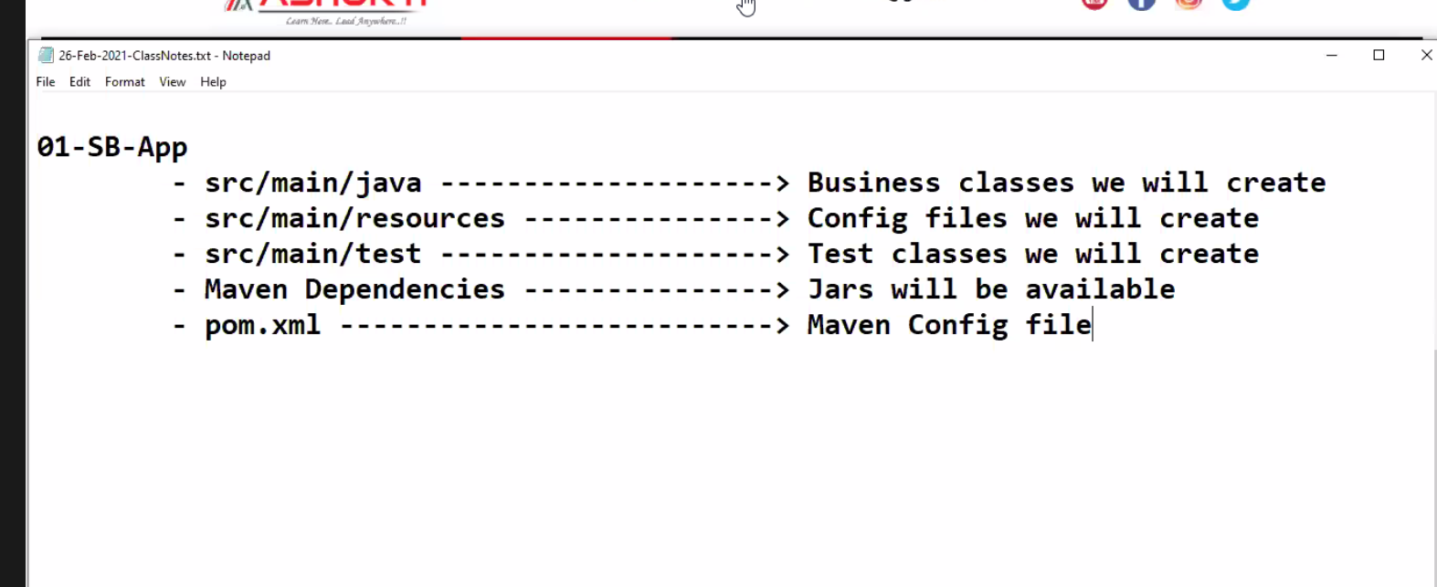

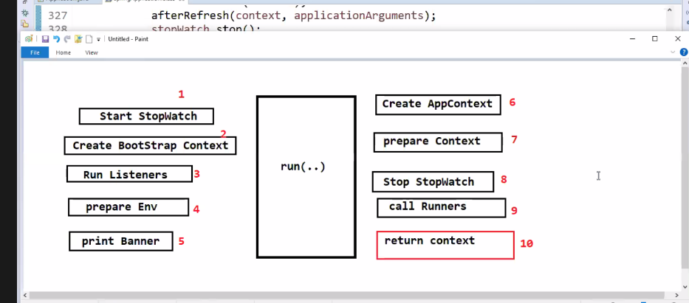

.

What is @SpringBootApplicaiton Annotation?

It equals to 3 annotations

1. @SpringBootConfiguration
2. @EnableAutoconfiguation
3. @ComponentScan

It is called as Classlevel Annotation. @SpringBootConfiguration represents our class as Configuration Class and we can write @Bean methods in our class

@EnableAutoConfiguration:- provides Auto Configuration functionalities for our application

@ComponentScan:- Provides functionalities to scan for spring Beans Available in Application

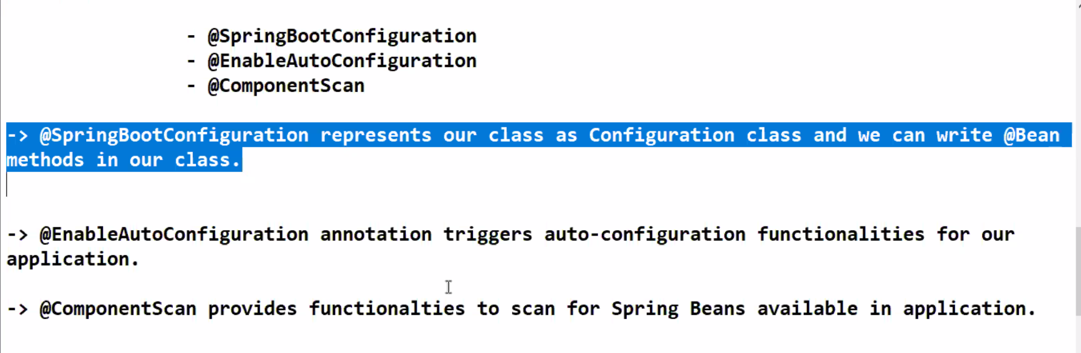

In Spring we need to enable ComponentScan but its default in Spring Boot. Object will be created automatically.

Component scan will use the base package naming convention to identify Spring Beans available in application

What is Base package in Spring Boot?

The package which contains Application.java(start class).

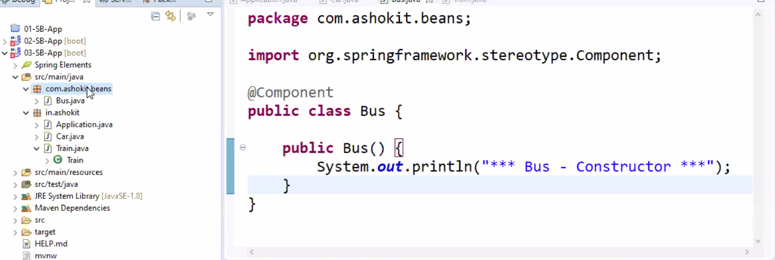

Component Scan will start from Base Package after that it starts the subpackages. The Packages start with the basepackage name is called subpackages.

Com.sattibabu--- base package

Com.sattibabu.Beans—will be scanned

Com.sattibabu.Controller ---will be scanned

In.sattibabu --- will not be scanned.

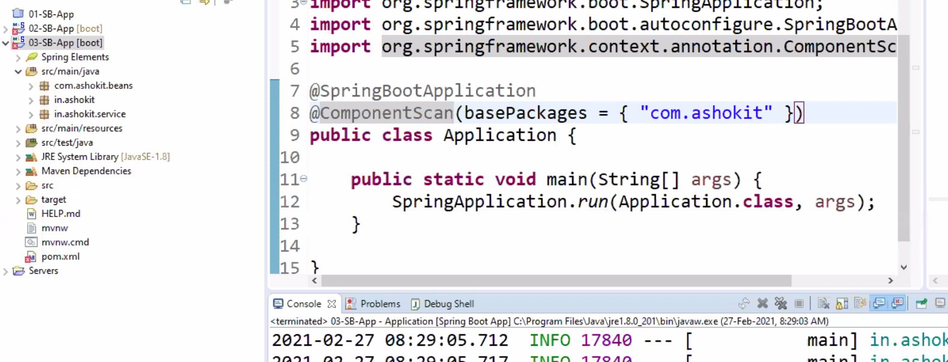

@SpringBootConfiguration:- This annotation represents our class as a Configuration. To customize the bean creation we can write @Bean methods in the class. This annotation internally uses the @Configuration

@EnableAutoConfiguration:-It configures the required configurations to run our Application.

**Features of Spring BOOT**

Creating IOC

Deploying the project into Emboded Container.

Configuring Front Controller

Connectiong Pool Creation

Embedded DB Support.

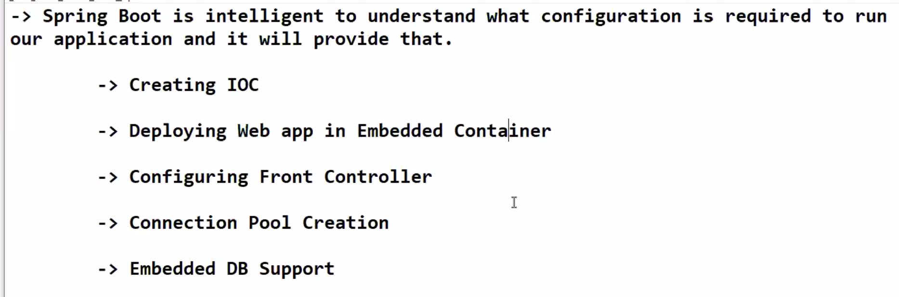

@ComponentScan:- Component Scan will start from Base Package after that it starts the subpackages. The Packages start with the basepackage name is called subpackages.

Com.sattibabu--- base package

Com.sattibabu.Beans—will be scanned

Com.sattibabu.Controller ---will be scanned

In.sattibabu --- will not be scanned.

**How to represent Java class as a Spring Bean?**

* The class which is managing by the IOC is called Spring Bean.
* There are several annotations are available to represent our class as Spring Bean.

@Component,@Service,@Repository,@Controller,@RestController,@Configuration,@Bean-🡪Method Level Annotaion.

@Service:- is used for Business logic

@Repository :- is used for persistence layer components deals with Database

@Component:- used for general purpose and used for Spring Bean

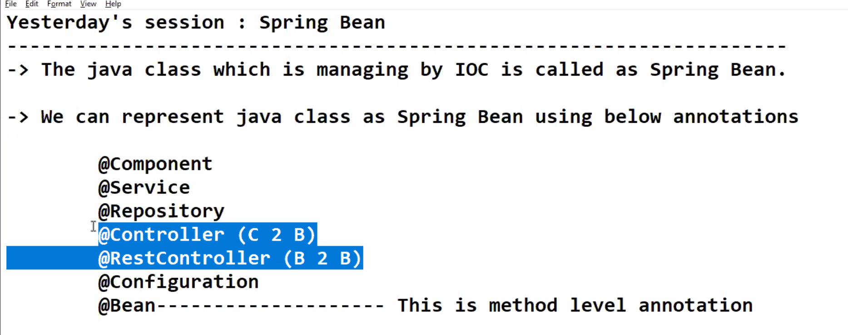

@Configuration:- used to represent as a Configuration class.

@Bean:- if we want to customize the Bean creation we will go for @Bean creation. Bean is a method level annotation rest are Class level annotation.

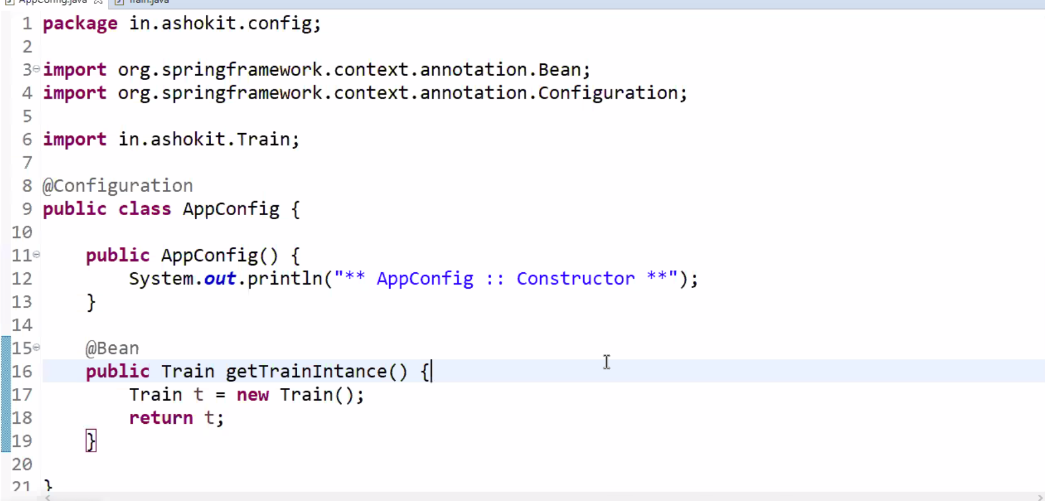

**09-03-2021**

Constuctor Injection:- By Using Parameterized Constructor. Dependent Object is injected to the Target Object through the Constructor.

@Autowired

Public class Car{ //Target Class

Private Engine eng;

@Autowired

Public Car(Engine eng){ //Target Constructor.

this.eng=eng;

}

}

Setter Injection:- Dependent Object is injected By Calling Setter method of the Target. Injecting through Setter Method

@Autowired

Public class Car{

Private Engine eng;

@Autowired

Public void setEng(Engine eng){

This.eng= eng;

}

}

Field Injection:- Dependent Object is Injected into the Target Object through the Reflection API is called Field Injection. If we use @Autowired at variable level IOC will perform field Injection.

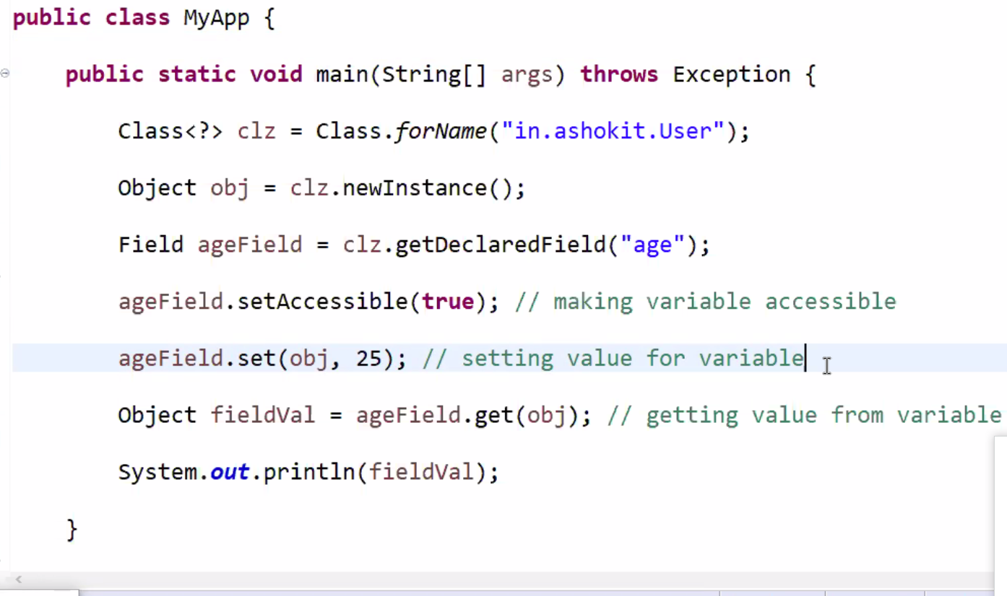

Accessing private variable outside of the Class by using Reflection API. When we go for the Field Injection. Whenever we specify @Autowired at field level . Can we use the private variable outside of the class Yes by using Reflection API.

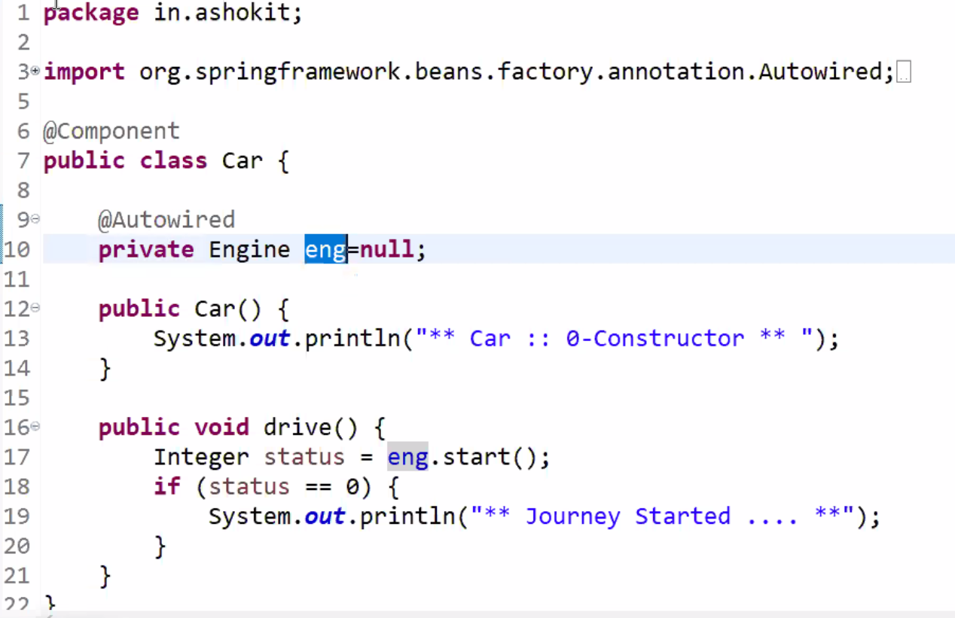

**10-03-2021**

**IOC:-** IOC is a principle to perform to injecting dependencies.

Field injection is not recommended because it violates the solid principles of OOPS. It is using the Reflection API.

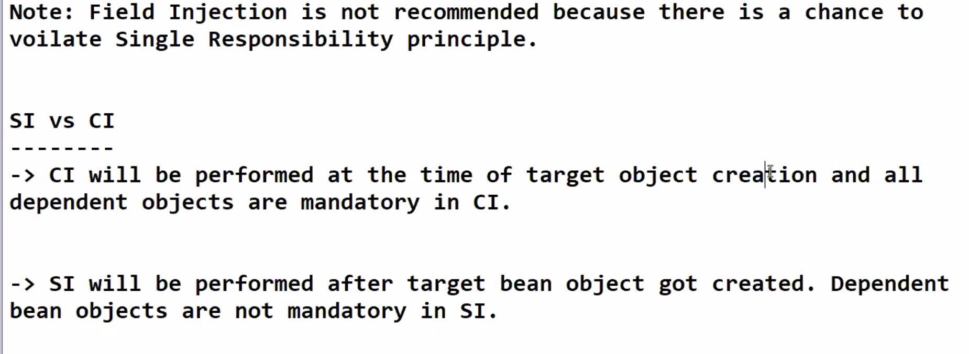

**Autowiring:-** Auto wiring is the process of identifying dependent obejcts and inject into the Target Class

Two types of Autowiring available. Default type of the Autowiring is byType. Identify dependent bean based on the datatype of the variable. If the Dependent object is an interface based on the implemented the class it will inject the object.

1. byType
2. byName

If we want to inject the IEngine object into Car class. It may have multiple implemented classes . So IOC will be confused which class object to be injected into IEngine interface. So we will use @Primary for the specific class to inject into Interface object.

@Component(“de”)

Class DieselEngine implements IEngine{

}

@Component(“pe”)

Class PetrolEngine implements IEngine{

}

@Autowired

@Qualifier(“de”)

IEngine eng;

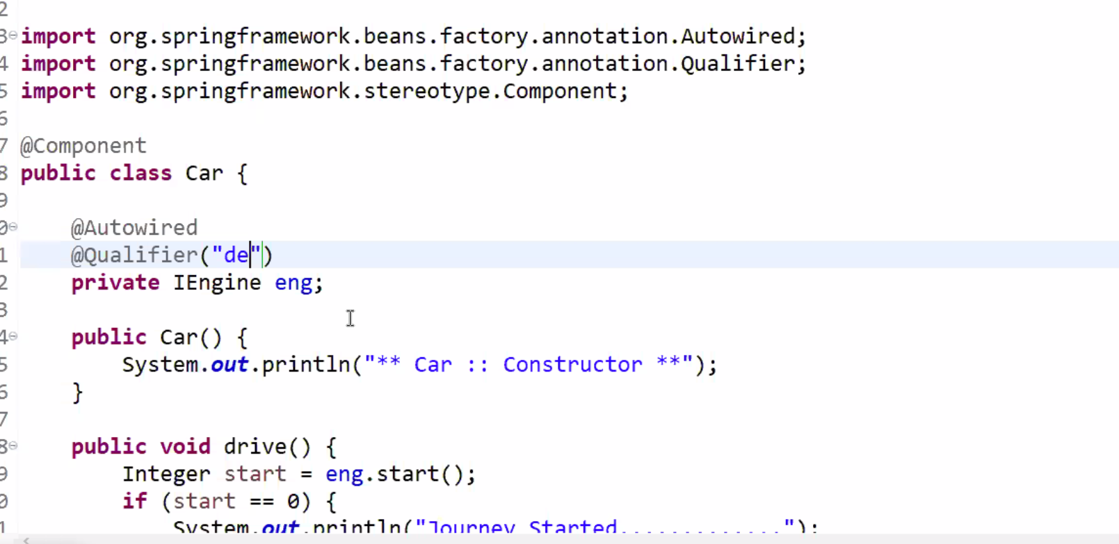

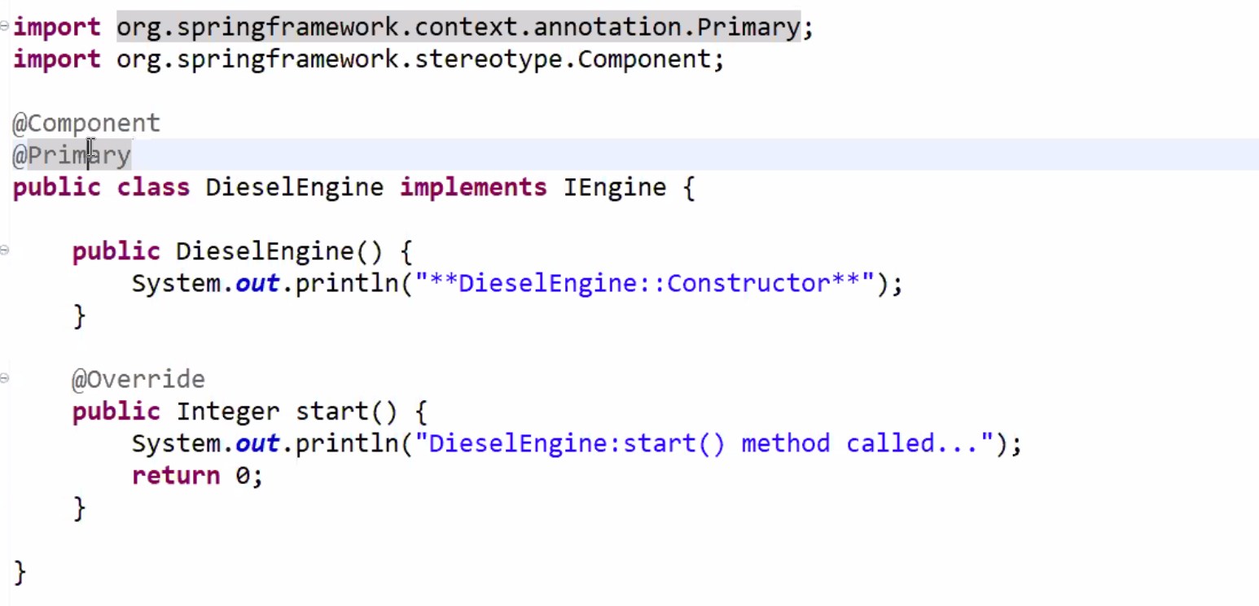

Autowiring:- Autowiring is the process of identifying the dependent object and inject into that target object. It is applicable for only object not into primitive and not for Wrapper classes.

**11-03-2021**

**Banner in Spring Boot:-**

When we run the Spring boot applications spring logo is printing on the console that is called as Banner. Banner printing is a part of SpringApplication.run(..)method.

Sprint Boot banner is have 3 below modes:-

1. OFF
2. LOG
3. CONSOLE(DEFAULT).

If we set the LOG banner will be printed in log file as well. We can customize banner text in Spring Boot by creating banner.txt file in src/main/resources folder. ASCII characters need to given.

spring.main.banner-mode=off

if we want to off the Banner. In src/main/resources folder.

**Runners in the Spring Boot:-**

What is Runner and Importance of Runners and Types of Runners?

Two types are available in Spring Boot

1. Application Runner
2. CommandLine Runner

Runners are used to execute the logic only one time once application bootstrapping is completed.

**UseCases:-**

Load Data into Cache

Configure cron jobs etc.

If we have runners in boot application then SpringApplication.run(..) method will call them.

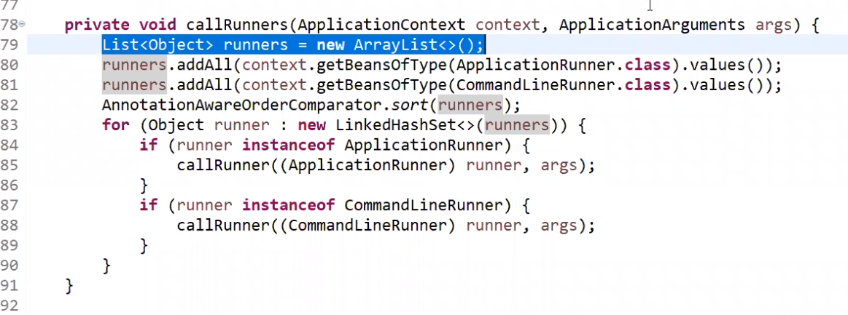

ApplicationRunner and CommandLineRunner are functional interfaces. Those consists of only one run method which takes arguments as args in ApplicationRunner.run() and args.getSourceArgs() in CommandLineRunner.

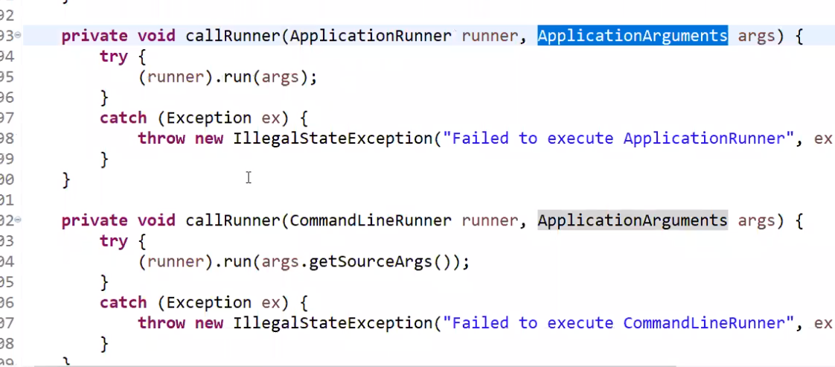

**13-Mar-2021**

**15-Mar-2021**

**Persistence Layer:-** This is used to Communicate with Database.

**Best Practice for Persistence Layer:-**

1. For every table we should create one DAO Class. If we don’t follow this there is a problem of Single Responsibility Principle.

Role_master Role_Master_DAO.java

User_Table User_Table_DAO.java

1. For Every Database Table we should have 4 columns
   1. createDate
   2. CreatedBy
   3. UpdateDate
   4. UpdtaedBy
2. For Every Table maintain a Primary Key
3. Primary key---Not Null & Unique
4. If we perform Search operations we should use the indexes in the table.
5. Create Connection pool to avoid connection Exhausted Problem.
6. Implement soft Delete for tables.--- Delete from Application level Inactive from the Table.
7. Use Generators to Generate the value for Primary Keys.
8. Write Database Independent Queries.

**16-Mar-2021**

By using Hibernate also we have to do some boiler plate code.

**Insert record using Hibernate**

**--------------------------------------------------------------------------------------------------------------------------------------------------------------------------------------------------------------------------------**

Configuration cfg=new Configuration();

Cfg.configure();

SessionFactory sf=cfg.buildSessionFactory();

Session hsession=sf.openSession();

Transaction tx=hSession.beginTransaction();

Hsession.save(query);

Tx.close();

**Inserting record using Spring JDBC**

**-------------------------------------------------------------------------------------------------------------------------------------------------------------------------------------------------------------------------------------**

JdbcTemplate jdbcTemplate;

jdbcTemplate.update(sql);

**Insert record using spring ORM**

HibernateTemplate hibTemplate;

hibTemplate.save(entityObj);

by using JDBC we are dealing with Text Data. When we go for hibernate we don’t go for text data we will use as objects. We have four options already why do we go for

Spring Data JPA:- For executing CRUD operations we have to perform 1000 times if we have 1000 tables. It’s again boiler plate code. Data JPA main purpose is used to reduce the boiler plate code while performing CRUD operations.

Public interface UserMasterDAO extends CrudRespository{

}

**17- Mar-2021**

Spring Data JPA provided predefined Interfaces to perform CRUD operations.

Environment setup for persistence Layer:-

1. Install Database Server ---Oracle
2. Install Database Client Server. ---SQL DEVELOPER

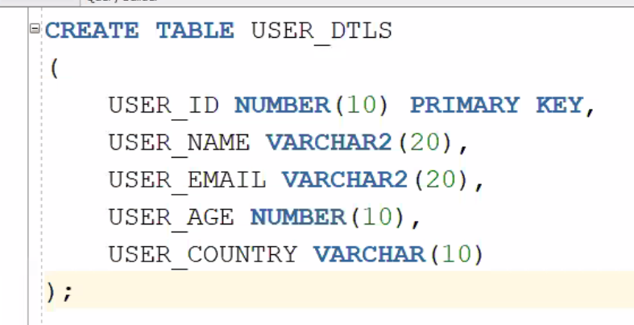

Steps to select the first application using DATA JPA

1. Spring-boot-starter-data-jpa
2. Oracle driver/ mysql driver /postres
3. Create entity class
4. Create Repository Interface by extending CrudRepository
5. Create configuration Datasource properties in application.properties
6. Call the repository methods to call them.

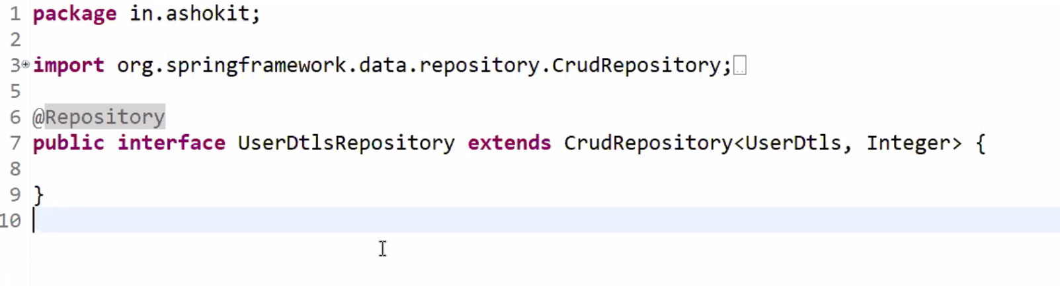

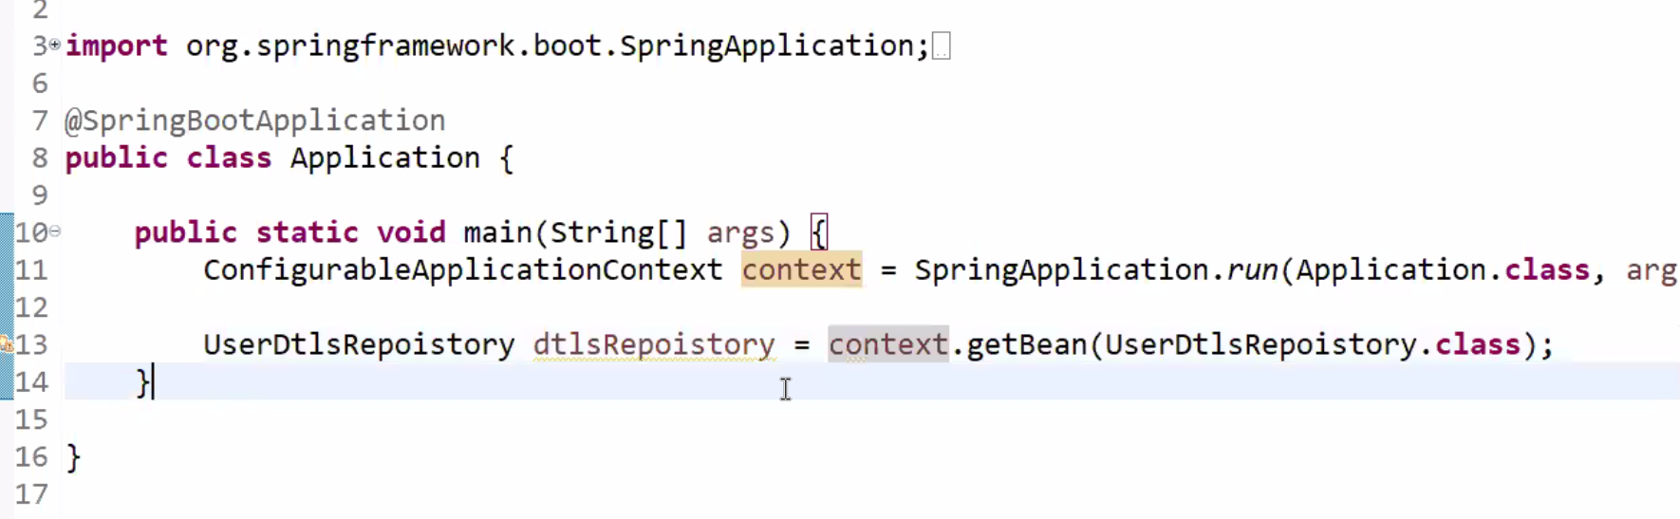

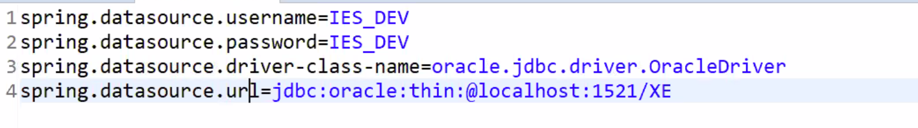

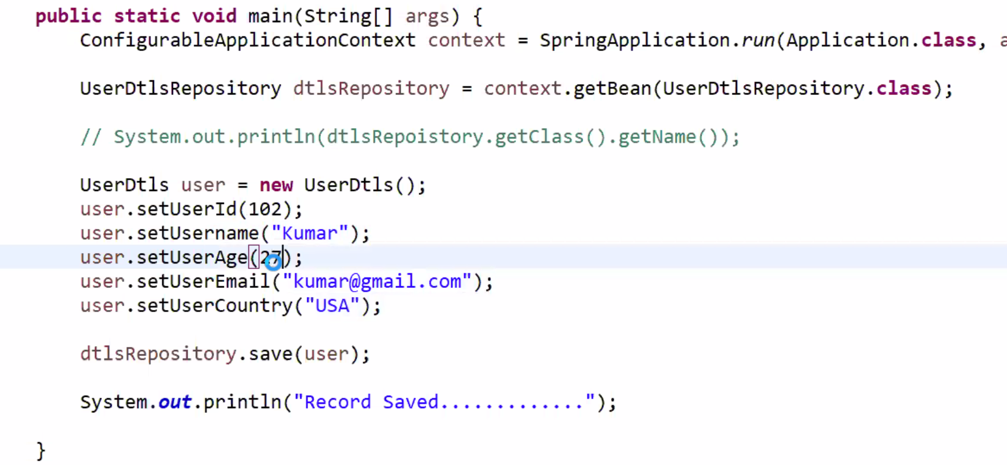

**20-Mar-2021**

**CrudRepository:-**  CrudRepository is a pre defined interface provided by Data JPA to perform CRUD operations. CRUD Repository has 11 methods

1. save()
2. saveAll()
3. findById();
4. findAllById();
5. findAll();
6. existsById();
7. count()
8. delete();
9. deleteById()
10. deleteAllById();
11. deleteAll();

we just need to call these methods in our class. We don’t have method to perform update operation. We can use the save method only to perform the update operation. When we call the save() method it will check the record exists with the primary key. If it exists it will update or otherwise it will insert the Data. 4

spring.jpa.properties.show_sql=true

**22-Mar-2021**:- No class

**23-Mar-2021**

When we write HQL queries database will not understand it should be converted by **Dialect** classes. We can configure the dialect classes in our property files.

@query(“ “) ---- HQL query

@query(value=” “, nativeSqlQuery=true);

SQL--- select * from EMP_DTLS will use Table names

HQL Query:- from Employee where empName=”ram”; ---It uses entity class name and entity properties.

SQL:- select emp_name from EMP_DTLS WHERE EMP_ID=401;

HQL:- select empName from Employee where empId=401;

**24-Mar-2021**

**Spring Data JPA Overview.**

CrudRepository is extending from Repository which is a marker interface. CrudRepository consists of 11 methods.

JpaRepository extends two more interfaces. PagingAndSortingRepository and QueryByExampleExecutor.

PagingandSortingRepository consists of 2 methods and QueryByExampleExecutor consists of 6 methods.

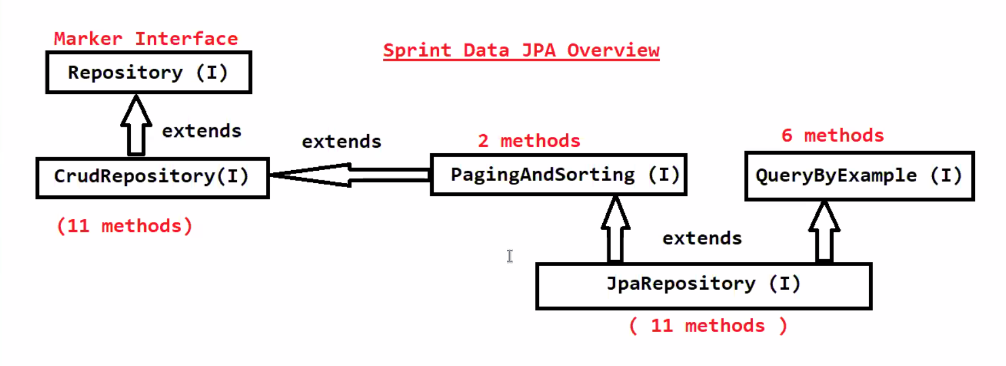

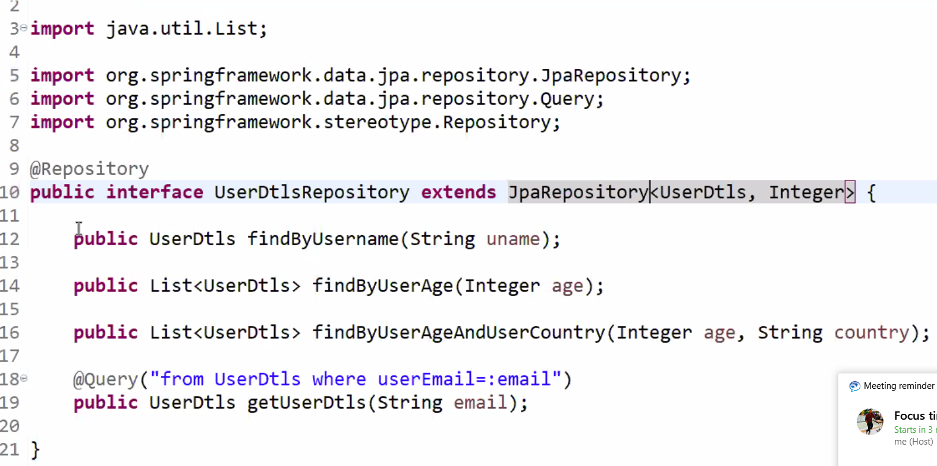

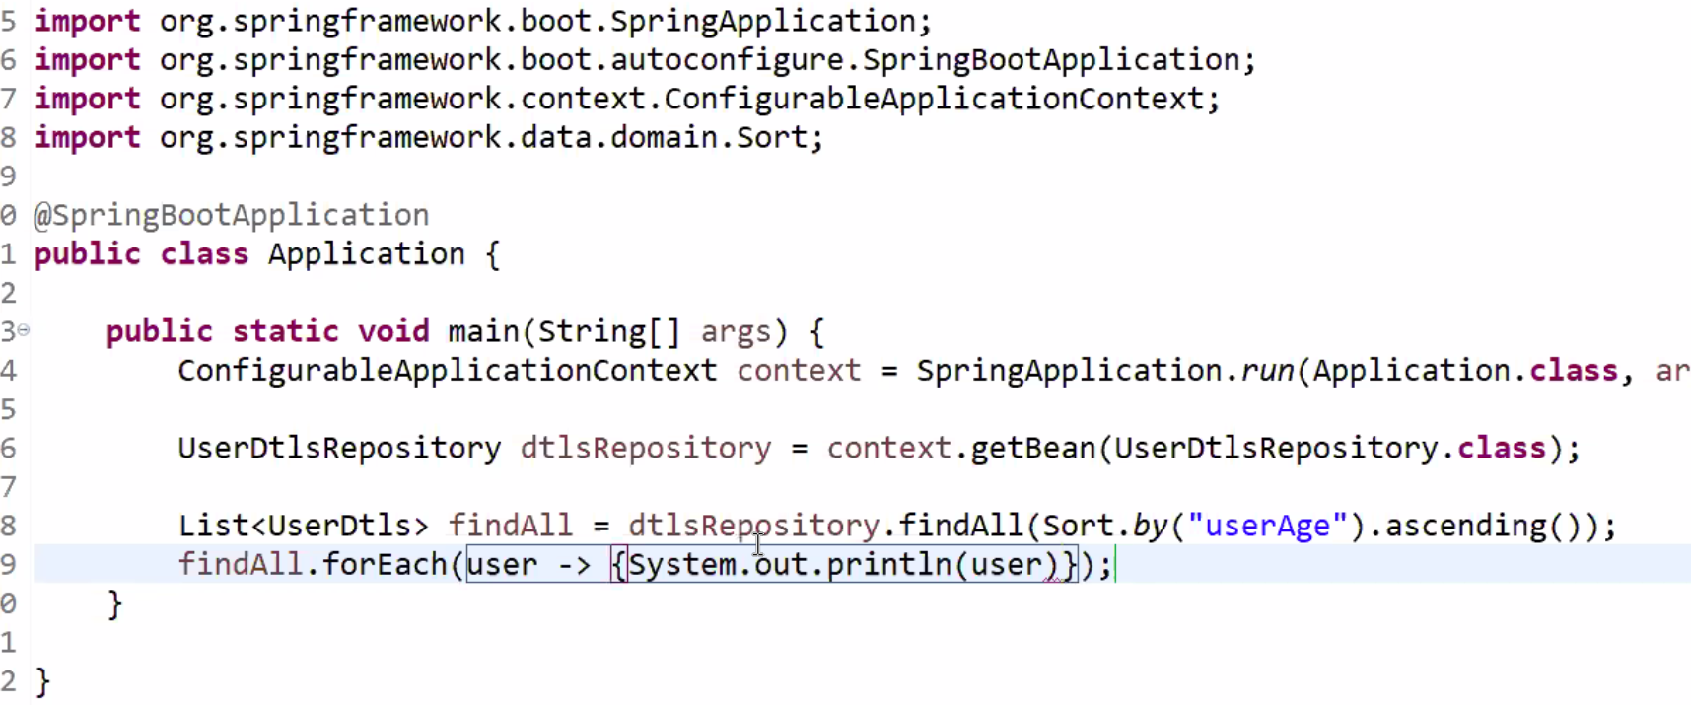

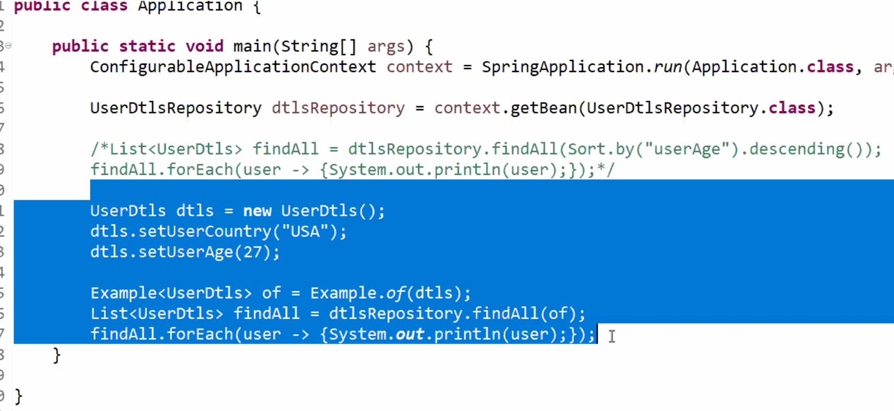

**We will use Example for Dynamic search.**

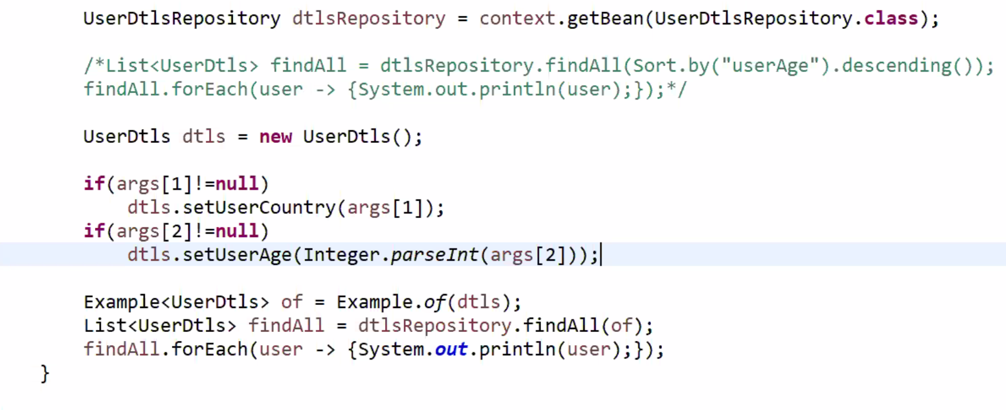

**Pagination:-** Dividing the records into multiple pages.

Pagable page=PageRequest(0,3);

Page<UseDtls> findAll=dtslRepository.findAll(page);

findAll.forEach(user->{System.out.println(user);});

25-Mar-2021—No class

**26-Mar-2021**

**Generators:-** Generators are used to configure the values to the primary key. It will use internally Hibernate_sequence for generating Primary key value.

How to create custom generator in Spring Boot?

@GeneratedValue(generator=”user_Seq”, strategy=”GenerationType.SEQUENCE”);

If we want to define our own generators

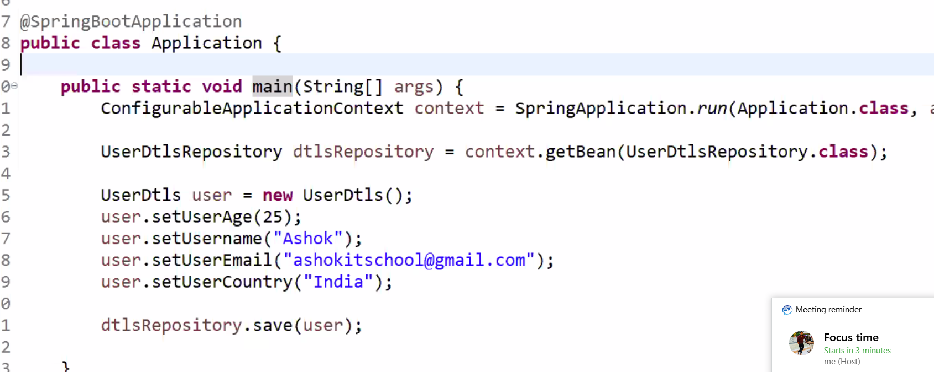

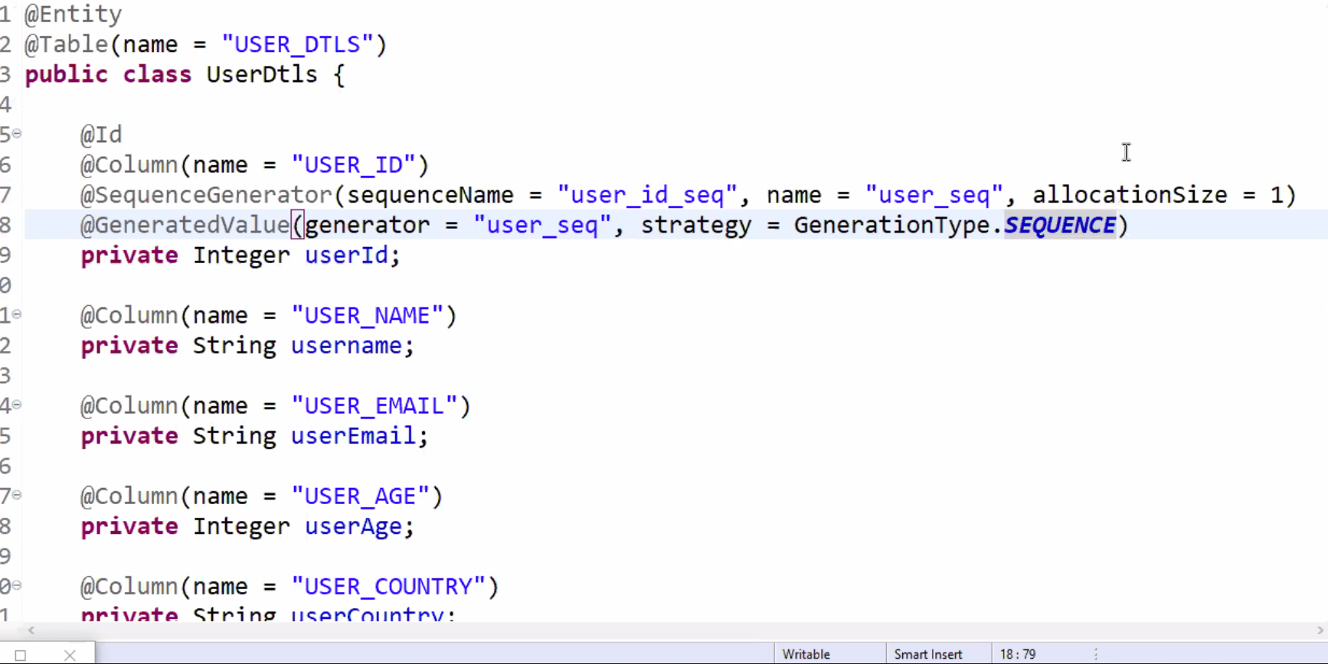

**Custom Generators:-**

Generators are used to generate the value for Primary key column. There are certain generators are available based on user requirement we will create custom generators.

Use case:- TCS emp id

TCS01,TCS02,

OD1,OD2,OD3.

To create custom generators we should implement the IdentifierGenerator interface. We have generator() method in the interface. We have to write the logic in that method. The primary key will be devided into two parts.

Prefix🡪OD

Suffix-🡪Number(starts with 1 increment by 1);

Step to Develop a Spring Data JPA with custom Generators.

1. **Creating Spring starter project with below dependencies**
2. Spring-boot-starter-data-jpa
3. Oracle driver
4. Lombok project
5. Create an entity class using annotations.
6. Create sequence in DB for suffix value generation.
7. Create custom generator class by implementing **Identifier** Generator Interface.
8. Configure custom generator in Entity.
9. Create Repository Interface by extending Repository Interface.

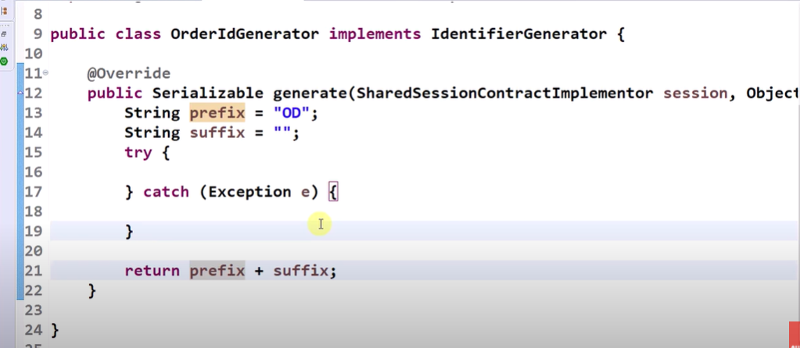

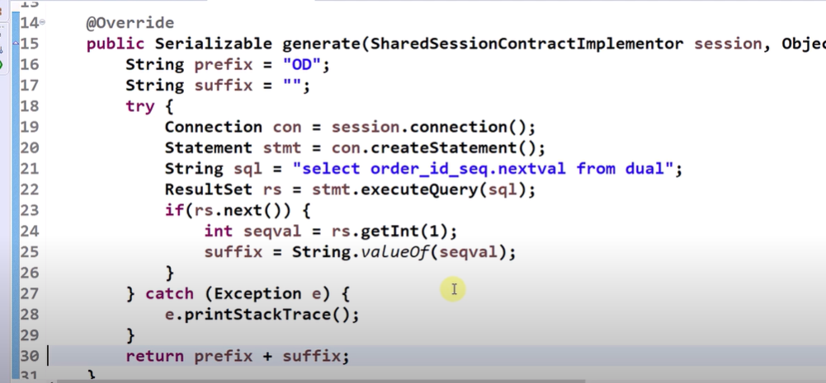

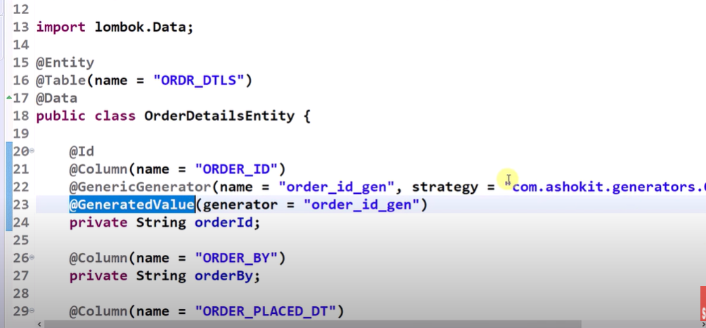

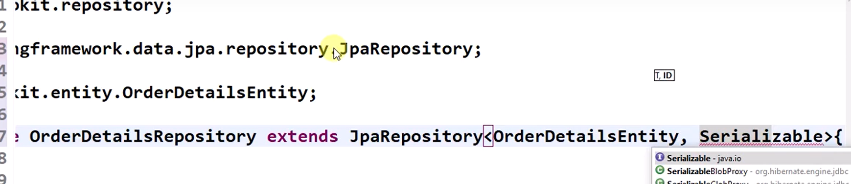

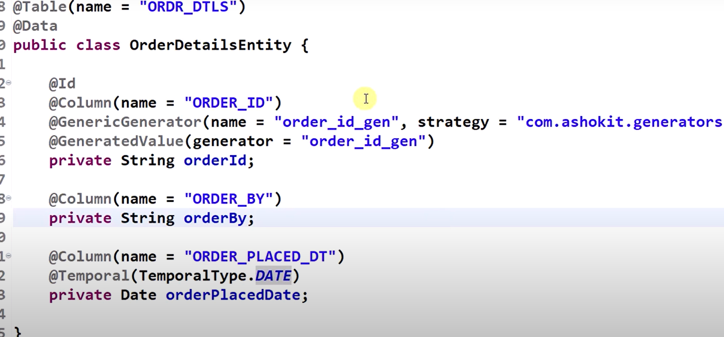

**Transaction Management:-**Unit amount of work is called a Transaction.

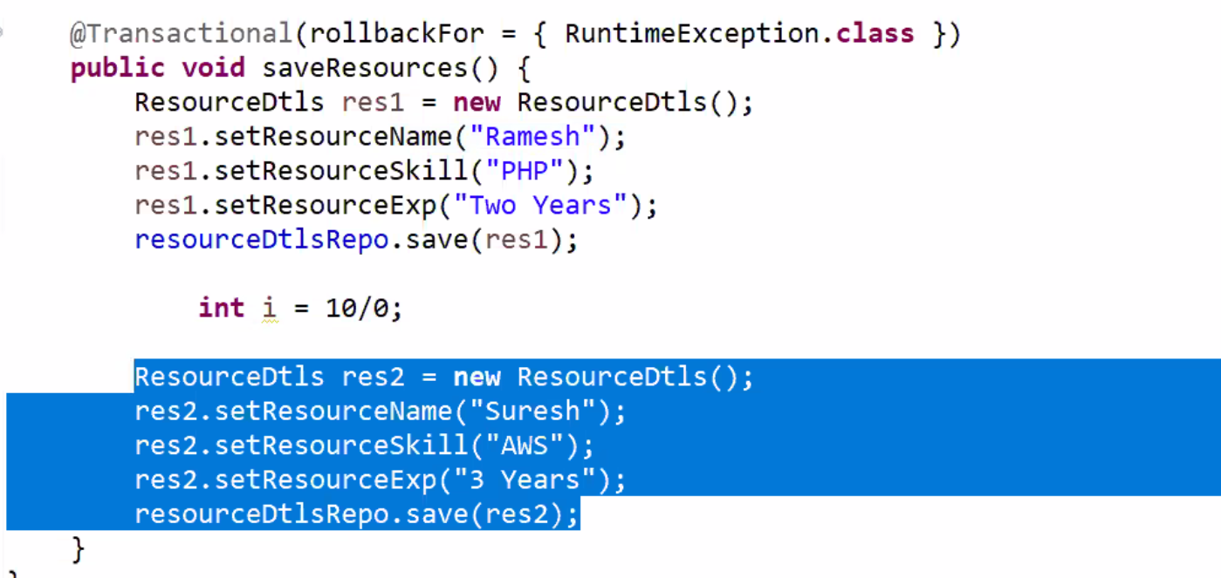

**30-03-2021**

**Connection Pooling:-**

To perform CRUD operations we need database connection. JDBC connects with DB by using

Connection con=DriverManager.getConnection(“”);

This is called physical connection.

If we use connection pooling. Data JPA will help to get connection this is called logical connection.

Spring Boot will use Hikari to connect with Database. If we don’t close Hikari will close the connections.

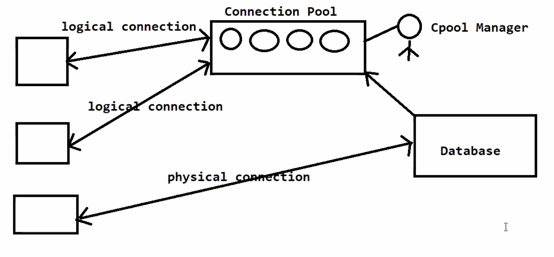

We can customize the Hikari Connection pool properties in Application.properties or Appliction.yml file.

Ideal time for Connection

Min size no of connections

Max size no of connections.

Spring.datasource.hikari.idleTimeout=1000

Spring.datasource.hikari.connectionTimeout=3000

Spring.datasource.hikari.maxLifetime=180000

In SpringBoot 1.x version we have to add the hikari dependency in pom.xml

In springBoot.2.x version its inbuilt property.

**31-Mar-2021**

**Spring MVC:-** Spring MVC is one of the module in the Spring frame work. It supports two types of applications.

1. Web Applications
2. Distributed Application

**Advantages of Spring MVC:-**

1. It supports loosely coupling
2. It supports form binding. It provides flexibility in form binding means it will take care of the type casting.
3. It can support multiple presentation technologies.
4. Components roles are clearly defined.

Every request should be handled by individual controller. For avoiding this we are using Spring MVC architecture. It uses front controller. It will take care of common logics required for all the controllers.

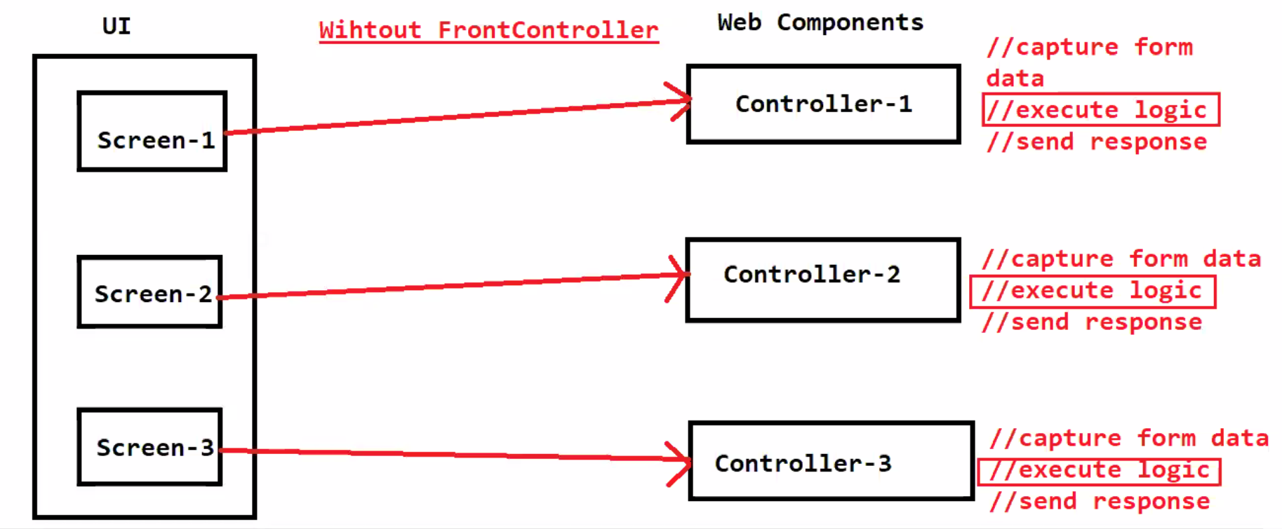

Spring MVC developed based on the two design patterns

1. MVC architecture
2. Front controller Design pattern

It is a layered architecture maintenance is very easy.

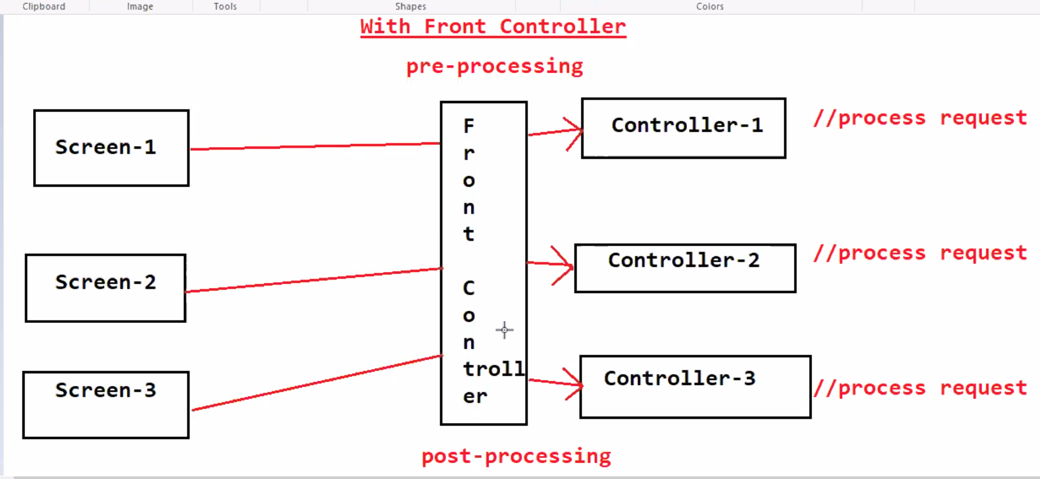

**Spring MVC Architecture:-**

1. Dispatcher Servlet
2. Handler Mapper
3. Controller
4. ModelAndView
5. View Resolver
6. View

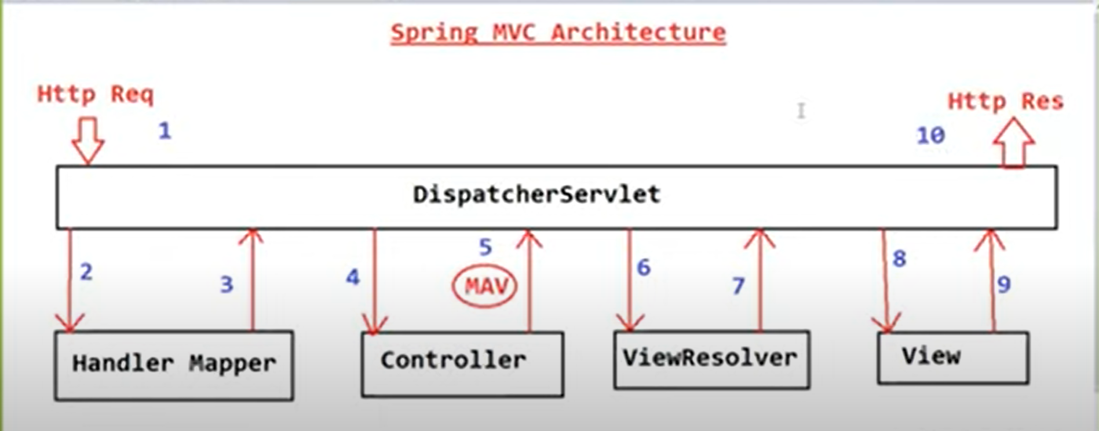

**01-Apr-2021**

Spring MVC module is developed based on 2 design patterns

1) MVC Design Pattern

2) FrontController Design Pattern

**02-Apr-2021**

1. Dispatcher Servlet:- Dispatcher Servlet is a pre-defined class available in Spring MVC and it is responsible to perform pre-processing and post-processing of a request. DispatcherServlet is called as Front Controller. Dispatcher Servlet Will Interact with HandlerMapper to identify Request Handler.
2. Handler mapper:-
3. Controller
4. ModelAndView
5. View Resolver:- DispatcherServlet will use "View Resolver" to identify location of view files and extension of view files. We will configure prefix and suffix for View Resolver to identify view files.

prefix = /views/ -------> location of views

suffix = .jsp -----> extension of views

1. View

**05-Apr-2021**

1. Create Spring Boot Application with below dependencies

1)spring-boot-starter-web

2)tomcat-embed-jasper

3)spring-boot-devtools

2) Create Controller Class using @Controller annotation

3) Create View File with Presentation Logic

4) Configure Server Port and View Resolver in application.properties file

5) Run the application and test it.

In Every Web application we will perform mainly two operations

1) Sending Data From Controller to UI

2) Sending Data from UI to controller

Sending Data From Controller To UI

----------------------------------

-> We can send data from Controller to UI using Model object in the form of key-value pair

Syntax: model.addAttribute(String key, Object value);

model.addAttribute("name", "Ashok");

model.addAttribute("user", userObject);

model.addAttribute("books", booksList);

-> Model data we can access in view file based on key

  Syntax : ${key}

We can send direct raw response also from controller using @ResponseBody annotation

@Controller + @ResponseBody = @RestController

import in.ashokit.domain.User;

@Controller

@RequestMapping("/user")

public class UserController {

@GetMapping

public String getUserData(Model model) {

User userObj = new User(101, "Ashok", "ashokitschool@gmail.com");

model.addAttribute("user", userObj);

return "user-data";

}

}

<%@ page language="java" contentType="text/html; charset=ISO-8859-1"

    pageEncoding="ISO-8859-1"%>

<!DOCTYPE html>

<html>

<head>

<meta charset="ISO-8859-1">

<title>Insert title here</title>

</head>

<body>

<h3>User Data</h3>

User Id : ${user.userId} <br/>

User Name: ${user.username} <br/>

Email : ${user.email}

</body>

</html>

<%@ page language="java" contentType="text/html; charset=ISO-8859-1"

pageEncoding="ISO-8859-1"%>

<%@ taglib uri="http://java.sun.com/jsp/jstl/core" prefix="c"%>

<!DOCTYPE html>

<html>

<head>

<meta charset="ISO-8859-1">

<title>Insert title here</title>

</head>

<body>

<h3>Books Available</h3>

<table border="1">

<thead>

<tr>

<th>Book Id</th>

<th>Book Name</th>

<th>Book Price</th>

</tr>

</thead>

<tbody>

<c:forEach items="${books}" var="book">

<tr>

<td>${book.bookId}</td>

<td>${book.bookName}</td>

<td>${book.bookPrice}</td>

</tr>

</c:forEach>

</tbody>

</table>

</body>

</html>

**07-Apr-2021**

 We can send data from UI to controller in below ways

1) Request Param

2) Path Param

3) Forms

If we want to send small piece of information then we will use Request Param or Path Param

Request Param and Path Param will represent data in URL directley

Using Forms we can send data in Request Body.

**08-Mar-2021**

When we submit form then form data will go to server in key-value format.

-> Spring MVC having form binding support. It will capture form data and will store into object.

-> Form fields keys should match with our class variables then form data will be store into objet.

-> If we submit form with GET request then form data will be appendend to URL (It is not secured).

-> Always it is recommended to submit form with POST request so that form data will go to server in Request Body.

-> To represent POST request we will specify method="POST" in <form/> tag

<form action="" method="POST">

.........

</form>

-------------------------------------------------------------------------

-> To simplify forms development Spring MVC provided Form Tag library

-> Spring MVC form tag library contains set of tags like below

<form:form>

<form:input>

<form:password>

<form:radioButton> & <form:radioButtons>

<form:select> & <form:option> & <form:options>

<form:checkbox> & <form:checkboxes>

<form:hidden/> etc...

-> Inorder to use spring mvc form tags in jsp, we should add taglib directive with spring mvc form tags url.

**10-Apr-2021**

As part of Form tag library several tags are available

form

input

password

radioButton

radioButtons

checkbox

checkboxes

select

option & options

package in.ashokit.domain;

import lombok.Data;

@Data

public class Student {

private String firstName;

private String lastName;

private String gender;

private String course;

private String timings;

}

-------------------------------------------------------------------------

package in.ashokit.controller;

import org.springframework.stereotype.Controller;

import org.springframework.ui.Model;

import org.springframework.web.bind.annotation.GetMapping;

import org.springframework.web.bind.annotation.PostMapping;

import in.ashokit.domain.Student;

@Controller

public class StudentController {

@GetMapping("/student")

public String loadForm(Model model) {

// Form Binding Object

Student s = new Student();

model.addAttribute("student", s);

// return logical view name

return "student";

}

@PostMapping("/student")

public String saveStudent(Student student, Model model) {

System.out.println(student);

model.addAttribute("succMsg", "Registration Successfull");

return "student";

}

}

------------------------------------------------------------------------

<%@ page language="java" contentType="text/html; charset=ISO-8859-1"

pageEncoding="ISO-8859-1"%>

<%@ taglib uri="http://www.springframework.org/tags/form" prefix="form"%>

<!DOCTYPE html>

<html>

<head>

<meta charset="ISO-8859-1">

<title>Insert title here</title>

</head>

<body>

<font color='green'>${succMsg}</font>

<form:form action="student" method="POST" modelAttribute="student">

<table>

<tr>

<td>First Name</td>

<td><form:input path="firstName" /></td>

</tr>

<tr>

<td>Last Name</td>

<td><form:input path="lastName" /></td>

</tr>

<tr>

<td>Gender</td>

<td><form:radiobutton path="gender" value="M" /> Male <form:radiobutton

path="gender" value="F" /> Fe-Male</td>

</tr>

<tr>

<td>Course</td>

<td><form:select path="course">

<form:option value="">-Select-</form:option>

<form:option value="java">Java</form:option>

<form:option value="testing">Testing</form:option>

<form:option value="python">Python</form:option>

</form:select></td>

</tr>

<tr>

<td>Timings</td>

<td>

<form:checkbox path="timings" value="mrng"/>Morning

<form:checkbox path="timings" value="noon"/>Afternoon

<form:checkbox path="timings" value="evng"/>Evening

</td>

</tr>

<tr>

<td></td>

<td>

<input type="submit" value="Register"/>

</td>

</tr>

</table>

</form:form>

</body>

</html>

**11-Apr-2021**

<dependency>

<groupId>org.springframework.boot</groupId>

<artifactId>spring-boot-starter-validation</artifactId>

</dependency>

package in.ashokit.domain;

import javax.validation.constraints.Email;

import javax.validation.constraints.NotEmpty;

import javax.validation.constraints.Size;

import org.springframework.beans.factory.annotation.Value;

import lombok.Data;

@Data

public class Student {

@NotEmpty(message = "{validation.firstName.notEmpty}")

@Size(min = 3, max = 8, message = "Minimum 3 and Maximum 8 characters are allowed")

private String firstName;

@NotEmpty(message = "{validation.lastName.notEmpty}")

private String lastName;

@NotEmpty(message = "{validation.email.notEmpty}")

@Email(message = "Please enter a valid e-mail address")

private String email;

private String gender;

private String course;

private String timings;

}

---------------------------------------------------------------------------------------------

package in.ashokit.controller;

import javax.validation.Valid;

import org.springframework.beans.factory.annotation.Autowired;

import org.springframework.stereotype.Controller;

import org.springframework.ui.Model;

import org.springframework.validation.BindingResult;

import org.springframework.web.bind.annotation.GetMapping;

import org.springframework.web.bind.annotation.ModelAttribute;

import org.springframework.web.bind.annotation.PostMapping;

import in.ashokit.domain.Student;

import in.ashokit.service.StudentService;

@Controller

public class StudentController {

@Autowired

private StudentService service;

@GetMapping("/student")

public String loadForm(Model model) {

// Form Binding Object

Student s = new Student();

model.addAttribute("student", s);

// return logical view name

return "student";

}

@PostMapping("/student")

public String saveStudent(@Valid Student s, BindingResult result, Model model) {

System.out.println(s);

if(result.hasErrors()) {

return "student";

}

//store form data in db

model.addAttribute("succMsg", "Registration Successfull");

return "student";

}

@ModelAttribute

private void loadFormData(Model model) {

System.out.println("******* loadFormData() method called ******");

model.addAttribute("genders", service.getGenders());

model.addAttribute("courses", service.getCourses());

model.addAttribute("timings", service.getTimings());

}

}

<%@ page language="java" contentType="text/html; charset=ISO-8859-1"

pageEncoding="ISO-8859-1"%>

<%@ taglib uri="http://www.springframework.org/tags/form" prefix="form"%>

<!DOCTYPE html>

<html>

<head>

<meta charset="ISO-8859-1">

<title>Insert title here</title>

</head>

<body>

<font color='green'>${succMsg}</font>

<form:form action="student" method="POST" modelAttribute="student">

<table>

<tr>

<td>First Name</td>

<td><form:input path="firstName" /></td>

<td><form:errors path="firstName" /></td>

</tr>

<tr>

<td>Last Name</td>

<td><form:input path="lastName" /></td>

<td><form:errors path="lastName" /></td>

</tr>

<tr>

<td>Email</td>

<td><form:input path="email" /></td>

<td><form:errors path="email" /></td>

</tr>

<tr>

<td>Gender</td>

<td><form:radiobuttons path="gender" items="${genders}" /></td>

</tr>

<tr>

<td>Course</td>

<td><form:select path="course">

<form:option value="">-Select-</form:option>

<form:options items="${courses}" />

</form:select></td>

</tr>

<tr>

<td>Timings</td>

<td><form:checkboxes items="${timings}" path="timings" /></td>

</tr>

<tr>

<td></td>

<td><input type="submit" value="Register" /></td>

</tr>

</table>

</form:form>

</body>

</html>

package in.ashokit;

import org.springframework.boot.SpringApplication;

import org.springframework.boot.autoconfigure.SpringBootApplication;

import org.springframework.context.MessageSource;

import org.springframework.context.annotation.Bean;

import org.springframework.context.support.ReloadableResourceBundleMessageSource;

import org.springframework.validation.beanvalidation.LocalValidatorFactoryBean;

@SpringBootApplication

public class Application {

public static void main(String[] args) {

SpringApplication.run(Application.class, args);

}

@Bean

public MessageSource messageSource() {

ReloadableResourceBundleMessageSource messageSource = new ReloadableResourceBundleMessageSource();

messageSource.setBasename("classpath:messages");

messageSource.setDefaultEncoding("UTF-8");

return messageSource;

}

@Bean

public LocalValidatorFactoryBean validator() {

LocalValidatorFactoryBean bean = new LocalValidatorFactoryBean();

bean.setValidationMessageSource(messageSource());

return bean;

}

}

-------------------------messages.properties---------------------------------------------

validation.firstName.notEmpty=First name should not be empty

validation.lastName.notEmpty=Last name should not be empty

validation.email.notEmpty=Email should not be empty